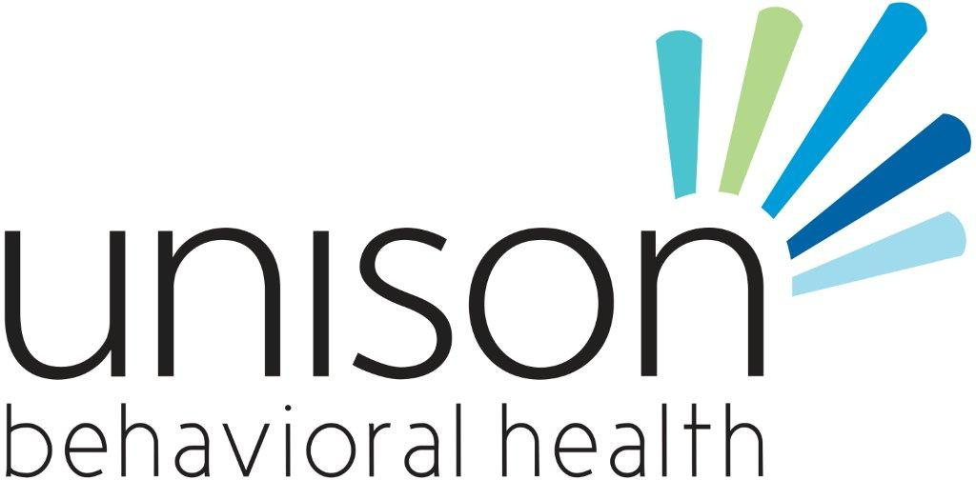

**Behavioral Health Professional IV**

**Location:** Coffee Child & Adolescent Behavioral Health **Closing date:** Open until filled

**Annual Salary:** $30,609

**Job Description:** Responsible for providing community support and skill training services to children and adolescents in school, home, and clinic settings; work closely with school staff and parents to address mental health needs of children and adolescents; group therapy.

**Job Responsibilities:** Will work Monday – Thursday 7:30– 5:30, Friday 8-12 Often times in non-traditional settings.

**Competencies:**

1. Knowledge of diagnostic impressions or criteria

2. Knowledge of how client advocacy system operates

3. Knowledge of individual and group therapy techniques

4. Knowledge of various therapeutic models and intervention as directly related to area of assignment

5. Knowledge of crisis intervention techniques

**Required Minimum Qualifications:** Bachelor's degree and one year experience in a social services related position. Prior case-management experience preferred.

ADDITIONAL NOTES:

Due to the volume of applications received, we are unable to provide information on application status by phone or e-mail. All qualified applicants will be considered, but may not necessarily receive an interview. Selected applicants will be contacted by the hiring agency for next steps in the selection process. Applicants who are not selected will not receive notification.  This position is subject to close at any time once a satisfactory applicant pool has been identified. UBH is a tobacco-free campus. UBH is a certified National Health Service Corps loan repayment agency.

We create health and wellness in our communities by providing quality mental health, substance abuse and developmental disability services.

**Submit application and cover letter by mail, email or fax to:**

**Shelly Bell, HR Department**

**P.O. Box 1397**

**Waycross, GA 31502**

**FAX: 912-449-7055**

[**sbell@unisonbh.com**](mailto:sbell@unisonbh.com)

**Submit resume and cover letter by mail, email or fax to:**

**Kim Smith, HR Department**

**P.O. Box 1397**

**Waycross, GA 31502**

**ksmith@satillacs.org**

**FAX: 912-449-7058**

[**ksmith@satillacs.org**](mailto:ksmith@satillacs.org)

***Unison Behavioral Health is committed to providing accessible, quality behavioral health and developmental disability services to individuals and families throughout southeast Georgia. We offer a full continuum of CARF accredited programs serving over 5900 individuals each year.***

***Unison Behavioral Health is an equal opportunity employer. A background check will be completed upon hire, which may consist of any of the following: FBI criminal history, employment history, educational records, and driving records.***